**Reactions and heat transfer along height**

The following graph was simulated in the reaction along height model, but i equated all the heats of reactions to zero. Therefore it is effectively only a heat transfer problem.

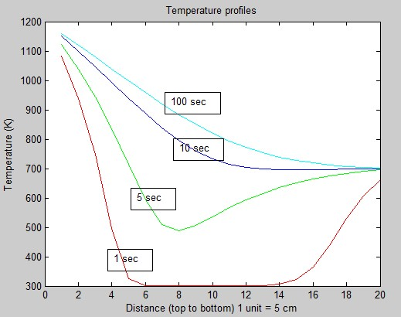

Observations:

* The graph looks accurate and it agrees with the results obtained in the previous model where only heat transfer was considered. This proves that there is no bug in the calculation of the temperature profiles.

**With reactions:**

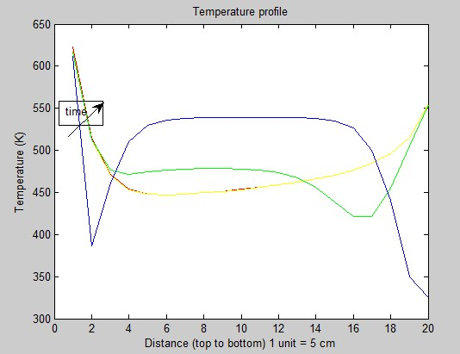

Clearly, the plots are incorrect, for the following reasons:

* Temperatures cannot be lower than that of the case when there is no reaction.
* In some regions the temperature is decreasing with increase in time.
* The initial temperature must be close to 1200 K since the temperature of the furnace is about 1200 K.

On examining the temperature vs. Time graph .

**Temperature vs time at the upper surface.**

When simulating for 100 s

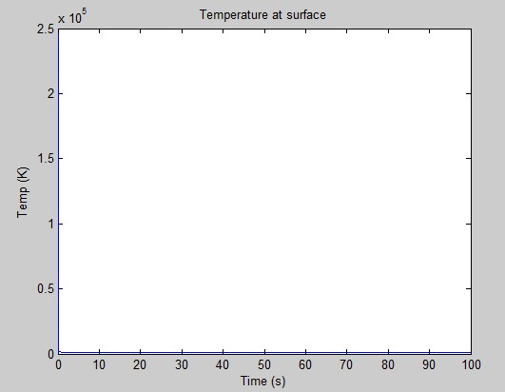

When simulating for 0.1 s.

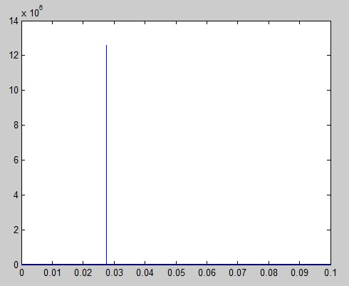

(Zooming in)

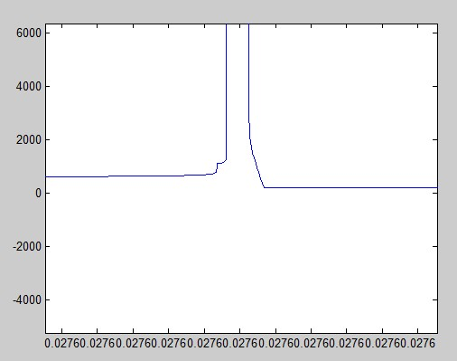

Possible explanations:

* The solver used is ode23tb , which is not supposed to be a very accurate solver. It was used since the problem demands the solution of 100s of odes to be solved simultaneously and none of the other solvers are able to solve it quickly enough.
* The properties of air and the biomass change significantly in the temperature range of 300 to 1200K. Perhaps, assuming those to be constant does not perfectly describe the problem.

Other methods:

* Use Laplace transform since, most reactions are first order.
* Do a discrete time method.